Purpose
The purpose of this quick reference guide is to help elected officials and other senior executives understand their responsibilities in the initial response to an incident.
These key decision makers work cooperatively with emergency management officials according to the responsibilities that the National Incident Management System (NIMS) describes. Additional information on the incident management roles of elected officials/senior executives and Multiagency Coordination Groups (MAC Groups) appears on NIMS pages 40 and 41.
This reference guide is organized into (a) overarching priorities that apply to every incident, (b) essential responsibilities, (c) what to expect, and (d) public messaging examples. Intentionally broad, the guide applies to diverse organizations across the nation. FEMA recommends that emergency managers customize this reference guide according to their Emergency Operations Plan (EOP) by including organizational points of contact (POC) and relevant operational details, such as how often the Emergency Operations Center (EOC) will provide situation reports. Emergency managers should review the customized reference guide with their leadership before an incident occurs.
Please remove this cover page before printing.

Incident Management Overview
As a senior leader, your primary responsibility is to support the senior executive in establishing overall incident policy, providing guidance on incident priorities, and ensuring that your organization’s resources are appropriately engaged in incident management. The overall incident management structure includes the following levels:
- Policy Group/Multiagency Coordination Group (MAC Group), which comprises your fellow elected officials and senior organizational leaders
- Emergency Operations Center (EOC) director, who oversees resource and planning support for on-scene personnel and ancillary activities such as sheltering and donations management
- Department Emergency Operations Center (DOC) manager, who coordinates closely with the EOC and manages and coordinates incident activities specific to a single functional area
- Public Information Officer (PIO), who ensures that the public receives accurate, timely, and consistent information about the incident
- Incident Commander (IC), who directs on-scene incident personnel responsible for saving lives, stabilizing the incident, and protecting property and the environment

Incident Management and Coordination
{Insert jurisdiction’s incident command chart below}
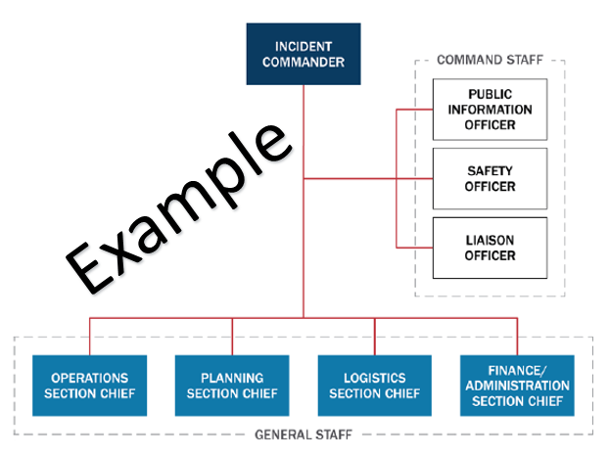

Overarching Priorities
- Life Safety: Ensure the safety and security of first responders, support personnel, and the general population.
- Unity of Effort: Coordinate and prioritize activities across all organizations involved in the response, to achieve common objectives.
- Incident Stabilization: Establish leadership to stabilize the incident and reduce future impacts.
- Protect Property and Environment: Protect infrastructure assets, systems, and networks, whether physical or virtual.
- Recovery: Reestablish services and help the community return to a new normal.

Senior Executive Essential Responsibilities
- Ensure the continuity of government.
- Activate specific legal authorities (disaster declarations, evacuations, states of emergency, and other protective actions).
- Coordinate with the PIO/Joint Information Center (JIC) to keep the media and public informed.
- Request assistance through the EOC director.
- Resolve any resource allocation conflicts.
- Coordinate with other elected officials and senior executives, including state and Federal offices, legislative delegations, and other dignitaries, to implement protective actions and ensure constituents’ safety and welfare.
- Request and authorize release and approval of funding.
- Participate in a MAC Group, if required.
- Initiate Continuity of Operations (COOP) plan or Continuity of Government (COG) plan as required.
- Coordinate with all ICs if multiple on-scene events occur.

What to Expect
- EOC gathers and analyzes incident information.
- EOC director provides situational assessments during an incident.
- EOC director receives questions and concerns.

Example Public Messaging
- We are aware that an incident has occurred (provide incident details, including time and location).
- At this time, (list agencies that are responding and give the response status). We are gathering additional information and will share it as it becomes available.
- At this time, we ask that the public (list requested actions, such as shelter in place or evacuate).
- Officials will release all those affected by the lockdown, including people in schools and daycare centers, once the area is safe.
- Public transit is currently (provide status).
- We will provide the public with up-to-date information via (list local media outlets, Facebook and Twitter accounts, and so on).

- Emergency Operations Center (EOC): (xxx) xxx-xxxx
- EOC Director: (xxx) xxx-xxxx
- Public Information Officer: (xxx) xxx-xxxx
- Joint Information Center: (xxx) xxx-xxxx

